Natural Language for Communication: Phrase Structure Grammars
1. Introduction
- Human communication relies heavily on natural language.
- To formally describe natural languages, grammatical models are used.
- One of the most widely studied models is the Phrase Structure Grammar (PSG), also called Constituency Grammar.

2. What is Phrase Structure Grammar?
- A phrase structure grammar is a set of rules that describes how words (lexical items) can be combined to form valid sentences in a language.
- It represents the hierarchical structure of sentences.
- Each sentence is broken down into phrases such as:
  - Noun Phrase (NP) – e.g., "the boy"
  - Verb Phrase (VP) – e.g., "is playing football"
  - Prepositional Phrase (PP) – e.g., "in the park"

3. Formal Definition
A phrase structure grammar (PSG) is defined as a quadruple:
G=(V,Σ,R,S)
Where:
- V → A finite set of non-terminal symbols (e.g., NP, VP, S).
- Σ → A finite set of terminal symbols (words of the language).
- R → A set of production rules (rewrite rules).
- S → The start symbol (usually "S" for Sentence).

4. Examples of Phrase Structure Rules
For English:
- S → NP VP
  - A sentence consists of a noun phrase followed by a verb phrase.
- NP → Det N | N
  - A noun phrase can be a determiner followed by a noun (e.g., "the dog") or just a noun (e.g., "dogs").
- VP → V NP | V NP PP | V
  - A verb phrase may be just a verb ("runs"), verb + NP ("eats food"), or verb + NP + PP ("put the book on the table").
- PP → P NP
  - A prepositional phrase consists of a preposition followed by a noun phrase.

5. Example Sentence Derivation
Sentence: “The boy eats an apple.”
Using rules:
- S → NP VP
- NP → Det N → "The boy"
- VP → V NP → "eats an apple"
- NP → Det N → "an apple"
Final Structure:
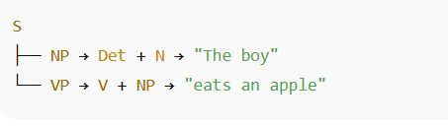
6. Phrase Structure Trees
PSGs are often visualized using parse trees, where each branch shows how a sentence is built from the rules.

Example:
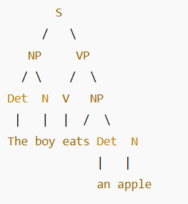
7. Applications in NLP
- Parsing: Analyzing the grammatical structure of sentences.
- Machine Translation: Understanding sentence structure before translation.
- Speech Recognition & Generation: Producing syntactically correct sentences.
- Information Extraction: Identifying entities and relationships in text.
Syntactic Analysis (Parsing in NLP / Compilers)
Definition:
Syntactic analysis, also called parsing, is the process of analyzing the structure of a sentence or a program according to the rules of a grammar. It checks whether a given sequence of words (in Natural Language Processing) or tokens (in compilers) follows the correct grammatical or syntactic structure.

In NLP (Natural Language Processing):
- Syntactic analysis determines how words are related to each other in a sentence.
- Example:
Sentence → “The boy eats an apple.”
  - Subject: The boy
  - Verb: eats
  - Object: an apple
- Parse Tree: Represents the grammatical structure.
Techniques in NLP:
- Constituency Parsing – Breaks sentences into sub-phrases (noun phrase, verb phrase).
- Dependency Parsing – Establishes direct relationships (dependencies) between words.

In Compilers (Programming Languages):
- Syntactic analysis is the second phase of compilation after lexical analysis.
- Input: Tokens from the lexical analyzer
- Output: Parse Tree / Abstract Syntax Tree (AST)
Goals:
- Check if the source code follows the grammar of the programming language.
- Report syntax errors.
- Generate a parse tree for semantic analysis.
Types of Parsers:
- Top-Down Parsing: Starts from the root and works towards the input (e.g., Recursive Descent, LL parsers).
- Bottom-Up Parsing: Starts from the input and works towards the root (e.g., LR parsers, Operator-precedence parser).

Difference Between NLP and Compiler Syntactic Analysis
Aspect | NLP | Compiler
Input | Natural language sentence | Source code tokens
Grammar | Phrase structure grammar | Programming language grammar (CFG)
Output | Parse tree / dependency structure | Parse tree / AST
Errors | Ambiguity in meaning | Syntax errors (strict rules)

✅ In short:
Syntactic analysis = Grammar checking + Parse tree construction.

Augmented Grammars and Semantic Interpretation
1. Augmented Grammars
- An augmented grammar is a grammar that extends the basic context-free grammar (CFG) by attaching additional information (attributes, actions, or conditions) to the grammar rules.
- These augmentations are used to capture semantic information and not just syntactic structure.
- They form the basis of syntax-directed translation in compilers and natural language processing (NLP).
Key Features:
- Attributes: Each grammar symbol (terminal or non-terminal) can have attributes (e.g., type, value, meaning).
- Semantic Rules: Each production rule in the grammar may have rules that compute attribute values.
- Translation: Attributes and rules allow the grammar to generate not just syntactic trees, but also semantic representations (like intermediate code, logical forms, or meaning structures).
Example:
For arithmetic expressions:
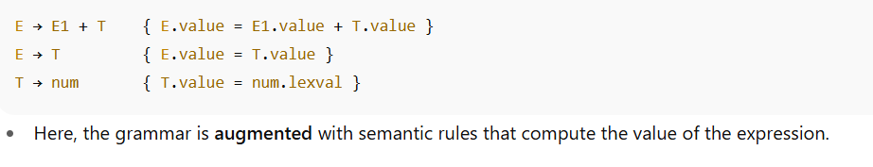
2. Semantic Interpretation
- Semantic interpretation is the process of mapping a syntactic structure (produced by parsing with an augmented grammar) into a meaning representation.
- In NLP, this might mean converting a sentence into a logical form or predicate structure.
- In compilers, this might mean generating intermediate code or abstract syntax trees (ASTs).
Steps in Semantic Interpretation:
- Parsing: Identify the syntactic structure using the grammar.
- Attribute Evaluation: Apply semantic rules to compute attribute values (e.g., type, meaning, value).
- Meaning Representation: Construct logical or executable representation (like a logical predicate, semantic graph, or machine code).
Example in NLP:
Sentence: “John loves Mary.”
Grammar Rule (augmented with semantics):
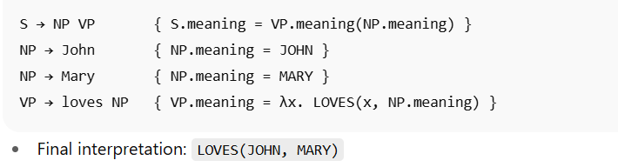
3. Applications
- Compiler Design: For syntax-directed translation and intermediate code generation.
- Natural Language Processing: For machine translation, question answering, dialogue systems.
- Knowledge Representation: For mapping language to logic or database queries.

✅ In short:
- Augmented Grammars = CFG + semantic rules (attributes & actions).
- Semantic Interpretation = process of deriving meaning (logical form, code, structure) from syntax using those augmentations.
Machine Translation (MT)
Machine Translation refers to the process of automatically translating text or speech from one natural language into another using computers. It is a key area in Natural Language Processing (NLP) and Computational Linguistics.

Definition
Machine Translation (MT) is the use of software to translate content (text/speech) from a source language (SL) to a target language (TL) without human intervention.

Approaches to Machine Translation
- Rule-Based Machine Translation (RBMT):
  - Uses linguistic rules, dictionaries, and grammar.
  - Relies on morphological, syntactic, and semantic analysis.
  - Example: Early systems like SYSTRAN.
- Statistical Machine Translation (SMT):
  - Based on statistical models trained on large bilingual corpora.
  - Uses probability distributions to find the most likely translation.
  - Example: Google Translate (before 2016).
- Neural Machine Translation (NMT):
  - Uses deep learning and neural networks.
  - Considers entire sentences, not just word-by-word translation.
  - Produces fluent, natural translations.
  - Example: Modern Google Translate, DeepL.
- Hybrid Approaches:
  - Combine rule-based, statistical, and neural methods.
  - Improve accuracy in domain-specific translation.

Key Components
- Source Language (SL): The language to be translated.
- Target Language (TL): The language into which translation is done.
- Bilingual Corpus: Large parallel datasets of translated text.
- Translation Engine: The algorithm/model used (RBMT, SMT, NMT).

Applications
- Multilingual communication (emails, chats, documents).
- International business and trade.
- Education and cross-language learning.
- Tourism (signboards, menus, directions).
- Government/UN translations.
- Real-time translation in video conferencing.

Challenges
- Ambiguity: Words with multiple meanings (e.g., “bank” – riverbank or financial institution).
- Idioms & Phrases: Literal vs. contextual meaning.
- Grammar Differences: Word order, gender, tense, etc.
- Domain-Specific Vocabulary: Technical/medical/legal terms.
- Cultural Nuances: Expressions may not directly map between languages.
Speech Recognition
Definition:
Speech recognition is the technology that enables a computer or machine to identify, process, and convert spoken language into text. It is a key area of Natural Language Processing (NLP) and Human-Computer Interaction (HCI).

Process of Speech Recognition
- Speech Input (Acoustic Signal):
The user’s voice is captured through a microphone.
- Preprocessing:
  - Noise reduction
  - Signal normalization
  - Feature extraction (e.g., MFCC – Mel Frequency Cepstral Coefficients)
- Acoustic Modeling:
  - Represents the relationship between phonemes (basic sound units) and audio signals.
- Language Modeling:
  - Uses grammar, vocabulary, and probability models to predict word sequences.
- Decoding:
  - Combines acoustic and language models to generate the most likely word output.
- Output:
  - Converts recognized speech into readable text.

Types of Speech Recognition
- Speaker-dependent vs. Speaker-independent
  - Speaker-dependent: Trained for a specific user.
  - Speaker-independent: Works for any speaker.
- Isolated-word recognition: Recognizes single words spoken with pauses.
- Continuous speech recognition: Handles natural, fluent speech.
- Command and control recognition: Used for executing commands (e.g., “Open file”).
- Large vocabulary vs. Small vocabulary systems

Applications
- Virtual Assistants (Siri, Alexa, Google Assistant)
- Dictation Software (Converting speech to text)
- Accessibility Tools (Helping people with disabilities)
- Customer Service Bots
- Voice Biometrics (Authentication and security)
- Transcription Services (Meetings, lectures, courtrooms)

Challenges
- Background noise and distortion
- Different accents and dialects
- Homophones (e.g., write vs. right)
- Continuous natural speech with slangs
- Real-time processing requirements
Perception and Image Formation
Perception is the process by which sensory input (like light) is captured, transformed, and interpreted to form meaningful understanding of the environment. In vision, this begins with image formation—the way light from the world projects onto a sensor (human eye or a camera).

Steps in Image Formation
- Light Emission or Reflection
  - Objects are visible because they emit light (like the sun, bulbs) or reflect light from other sources.
  - The reflected light carries information about the surface properties (color, texture, shape).
- Propagation of Light
  - Light travels through the environment as rays or waves.
  - In geometric optics, light is modeled as straight rays.
- Interaction with Imaging Device (Eye or Camera)
  - Human Eye: Light enters through the cornea and lens, which focus the rays onto the retina (like a screen).
  - Camera: Light passes through a lens and projects onto the image plane/sensor (CCD/CMOS).charge coupled device /complementary metal oxide-semiconductor.
- Projection to Image Plane
  - A 3D scene is projected into a 2D image.
  - This projection introduces perspective, where closer objects appear larger than distant ones.
- Sampling and Recording
  - In the eye, photoreceptor cells (rods and cones) convert light into electrical signals.
  - In cameras, pixels on the sensor capture light intensity and color values.
- Perceptual Interpretation
  - The brain (or computer algorithms in machine vision) reconstructs information about objects—shape, depth, motion, and identity—from the image.

Mathematical Model of Image Formation
- A pinhole camera model is often used:
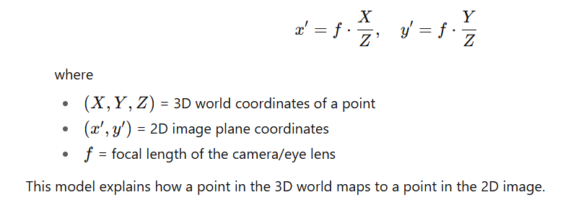
Key Factors Affecting Image Formation
- Illumination (lighting conditions)
- Surface properties (reflective, matte, transparent)
- Optics (lens quality, focal length, aperture)
- Sensor properties (resolution, sensitivity, noise)
Early Image Processing Operations
Early image processing refers to the initial, low-level operations applied to digital images to improve their quality, extract basic features, or prepare them for higher-level analysis (like object recognition, segmentation, or classification). These operations generally work directly on pixel values and are computationally simple.

1. Image Acquisition
- The first step in image processing.
- Capturing an image using a sensor (camera, scanner, satellite, etc.).
- Includes digitization (converting continuous image → discrete pixels).

2. Image Enhancement
Improves visual appearance or makes certain features more detectable.
- Contrast Adjustment (stretching or equalization).
- Smoothing / Blurring (reduces noise using filters like average or Gaussian).
- Sharpening (enhances edges using Laplacian or high-pass filters).
- Histogram Processing (adjusting brightness/contrast).

3. Image Restoration
- Corrects degradations that occur during image capture or transmission.
- Noise Removal (salt & pepper noise, Gaussian noise).
- Deblurring (motion blur, out-of-focus blur).
- Uses mathematical models of degradation.

4. Color Processing
- Converting between color models (RGB, HSV, Grayscale).
- Enhancing color contrast.
- White balance adjustment.

5. Point Processing Operations
Operate on each pixel individually.
- Image Negative: s = L-1 - r (inverts brightness).
- Thresholding: separates object from background.
- Log & Power-law Transformations: enhance details in dark or bright regions.

6. Neighborhood (Spatial) Processing
Use values of a pixel and its neighbors.
- Smoothing filters (mean, median).
- Edge detection (Sobel, Prewitt, Canny).
- Morphological operations (erosion, dilation for binary images).

7. Geometric Operations
- Changing image geometry (scaling, rotation, translation).
- Correcting distortions.
Object Recognition by Appearance
Object Recognition by Appearance is a technique in computer vision where objects are identified based on how they look, rather than by explicitly modeling their shape, structure, or geometry. Instead of analyzing the 3D structure of objects, this approach relies on visual features extracted directly from the object’s image or appearance.

Key Ideas
- Appearance-based methods use image patterns such as intensity, color, and texture to recognize objects.
- Objects are represented by their visual features instead of geometric models.
- Recognition is achieved through pattern matching between stored appearance models and new input images.

Steps in Appearance-based Object Recognition
- Image Acquisition – Capture the object image using a camera or sensor.
- Feature Extraction – Extract visual features such as:
  - Edges and corners
  - Color histograms
  - Texture descriptors
  - Local descriptors (e.g., SIFT, SURF, ORB)
- Feature Representation – Represent the object in a feature space (e.g., high-dimensional vectors).
- Model Learning – Use machine learning to store object appearance patterns (e.g., PCA, Neural Networks, Deep Learning).
- Recognition / Classification – Match extracted features from the test image with stored models.

Techniques Used
- Template Matching – Direct comparison of pixel intensity patterns.
- Eigenfaces / Eigenobjects (PCA) – Reducing dimensionality and recognizing based on principal components.
- Bag of Visual Words (BoVW) – Representing images as distributions of feature "words."
- Deep Learning (CNNs) – Learning appearance features automatically for robust recognition.

Advantages
- Works well with real images where geometric modeling is difficult.
- Can handle complex objects without needing 3D structure.
- Effective for face recognition, handwriting recognition, and object categorization.

Limitations
- Sensitive to lighting, viewpoint, and occlusion.
- Requires large training datasets for high accuracy.
- May confuse objects with similar appearance but different structure.

Reconstructing the 3D World
Reconstructing the 3D world refers to the process of creating a three-dimensional representation of real-world objects or scenes from sensory data, usually obtained through cameras, depth sensors, or other imaging technologies. It is a fundamental problem in computer vision, robotics, and augmented reality.

1. What It Means
- Transforming 2D sensor data (like images, video, or laser scans) into a 3D model.
- Estimating the shape, depth, and spatial relationships of objects in the scene.

2. Techniques for 3D Reconstruction
- Stereo Vision
  - Uses two or more cameras from slightly different viewpoints.
  - Depth is estimated by comparing differences (disparity) between the images.
- Structure from Motion (SfM)
  - Uses multiple 2D images taken from different camera positions.
  - Estimates camera motion and reconstructs 3D structure simultaneously.
- Photometric Stereo
  - Multiple images under different lighting conditions.
  - Infers surface normals and reconstructs 3D shape.
- Shape from Shading
  - Infers 3D surface information from shading variations in a single image.
- Depth Sensors
  - Devices like LiDAR, Time-of-Flight cameras, Kinect provide direct depth measurements.
- Multi-View Stereo (MVS)
  - Combines images from many viewpoints to build dense 3D point clouds or meshes.

3. Mathematical Foundations
- Camera Model: Perspective projection equations.
- Epipolar Geometry: Relates 3D points to image correspondences.
- Triangulation: Used to compute depth from multiple views.
- Optimization: Bundle adjustment refines 3D points and camera parameters.

4. Applications
- Robotics: Navigation, obstacle avoidance, SLAM (Simultaneous Localization and Mapping).
- Autonomous Vehicles: 3D mapping for environment understanding.
- Medical Imaging: 3D reconstructions from CT/MRI scans.
- Cultural Heritage: Reconstructing artifacts or monuments in 3D.
- AR/VR: Building immersive environments from real-world data.

Object Recognition from Structural Information
Object recognition can be done not only by appearance (color, texture, intensity) but also by structural information—that is, how parts of an object are related to each other. Instead of recognizing an object as a whole template, this method analyzes its geometry, topology, and relationships among components.

Key Ideas
- Structural Representation
  - Objects are described in terms of primitives (basic parts) and the relations among them.
  - Example: A chair can be represented as seat + backrest + 4 legs, with spatial relations like “legs under seat,” “backrest behind seat.”
- Parts-Based Models
  - Objects are decomposed into smaller components (edges, corners, surfaces).
  - These parts are arranged in a hierarchical structure.
- Graph-Based Representation
  - Structural information is often stored in graphs:
    - Nodes = object parts.
    - Edges = spatial/functional relations.
  - Recognition involves graph matching between observed image structure and stored models.

Methods of Using Structural Information
- Geometric Descriptions
  - Shape is described by geometric primitives (lines, arcs, polygons, cylinders).
  - Recognition checks whether the arrangement of primitives matches a known model.
- Topological Descriptions
  - Focus on connectivity (e.g., “this part is attached to that part”).
  - Robust to size, orientation, and deformation.
- Attributed Relational Graphs (ARGs)
  - Graphs enriched with attributes (length, angle, color).
  - Matching requires comparing both structure and attributes.
- Structural Pattern Recognition
  - Uses grammars or rules (like in language) to describe valid object structures.
  - Example: A human face grammar might be: Face → Eyes + Nose + Mouth with constraints on spatial arrangement.

Advantages
- Handles complex objects by decomposing them.
- More robust to changes in viewpoint, scale, or partial occlusion than pure template matching.
- Mimics how humans often recognize objects: by identifying parts and their configuration.

Limitations
- Extracting reliable primitives and relationships from noisy images is difficult.
- Graph matching is computationally expensive.
- Less effective for objects with high texture variation but weak structural cues.

Using Vision in Perception
Vision plays a crucial role in perception, as it allows humans and machines to interpret and understand the surrounding environment by processing visual information. In the context of Artificial Intelligence (AI) and Cognitive Science, vision refers to the ability to capture, analyze, and interpret images or scenes to form meaningful representations of the world.
Key Aspects of Using Vision in Perception:
- Image Acquisition
  - The first step involves capturing visual input using sensors such as cameras or biological eyes.
  - The raw data is in the form of light intensity patterns.
- Low-level Vision (Early Vision Processing)
  - Detects edges, colors, textures, and motion.
  - In humans, this is done by the retina and early visual cortex.
  - In computers, techniques like filtering, edge detection, and feature extraction are used.
- Mid-level Vision
  - Organizes basic features into meaningful shapes, surfaces, and regions.
  - Includes segmentation, depth perception, and 3D reconstruction.
  - Helps in distinguishing objects from background (figure-ground separation).
- High-level Vision (Recognition & Interpretation)
  - Involves object recognition, scene understanding, and spatial relationships.
  - Human brain uses memory and context to interpret what is seen.
  - In AI, machine learning and neural networks are applied for classification and recognition.
- Integration with Other Modalities
  - Vision works with other senses (hearing, touch) for better perception.
  - For example, visual cues enhance speech perception (lip reading).
- Applications of Vision in Perception
  - Human Perception: Understanding environment, navigation, interaction.
  - Computer Vision: Self-driving cars, medical imaging, facial recognition, robotics.

